(40 points): Create a Windows Forms application named Question2 to edit information of a ship.
- User Interface (10 points)
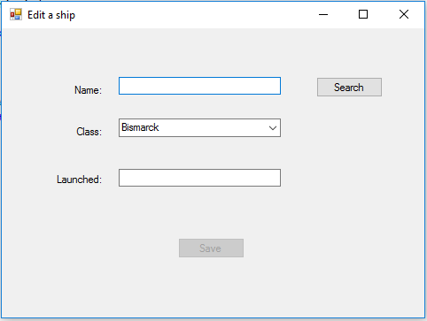
Note:
- Display the list of classes ordered by ascending of names from “Classes” table (5 points)
- Button “Save” is disabled.
- Event “TextChanged” of “Name” textbox (3 points)
- Enable “Search” button.
- Disable “Save” button.
- Event “Click” of “Search” button (12 points)
- If enter value “Kongo” for “Name” textbox, then (5 points)
  - Display information of this ship.
  - Disable “Search” button.
  - Enable “Save” button.
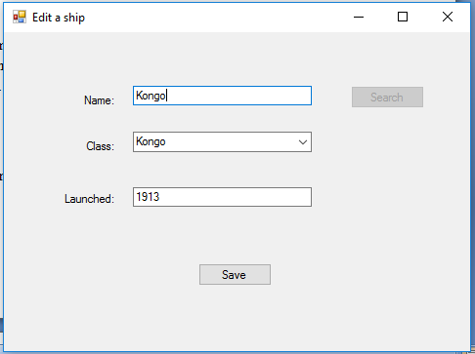
- If don’t enter any value for “Name” textbox then display a message: (2 points)

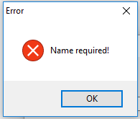
- If enter value “Kongo1” for “Name” textbox then display a message: (5 points)
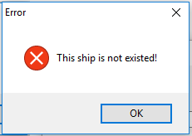
4. Event “Click” of “Save” button (15 points)
- Update information of the ship (10 points).
- Display a message (5 points):
